SmartCare v0.2 - Requirements Specification Template

Problem and Scope
SmartCare Community Clinic currently manages patient information and appointments using spreadsheets, paper records, and manual processes. This has led to operational inefficiencies, such as duplicate appointment bookings, inability to access patient records, inconsistent information about the status of appointments, lack of visibility into practitioner availability, manual cancellations, and a lack of appointment history.
This initial version of the software will address these issues and replace them with a simple, centralised software system. The system will focus on three areas: Patient Management, Practitioner Management, and Appointment Management. It will allow clinic staff to register patients, practitioners, book appointments, avoid duplicates, cancel appointments, and view basic schedules and reports.
This version of the system will not include more complex hospital information system features such as billing, insurance claims, external laboratory systems, patient-facing portals, or advanced medical record keeping. It will be an application, manageable by a small community clinic, iteratively developed.

2. Stakeholders
Stakeholder | Need | Evidence
Reception/Staff | An efficient booking system, quick patient lookup, easy cancellation processes, and a single source of truth for appointments. | Case study: “difficulty locating patient records”, “duplicate appointment bookings”,” manual cancellation processes”.
General Practitioners (GPs) | Clear visibility of their daily schedules, easy access to patient records, and reduced scheduling conflicts. | Case study: “limited visibility of practitioner availability”.
Clinic Management | Accurate operational reports, reduced administrative overhead, and a reliable overview of clinic activity. | Case study: “difficulty producing basic operational reports”, “lack of reliable appointment history”.
Patients | A reliable booking process, no duplicate appointments, and confidence that their records are accurate. | Case study: “duplicate appointment bookings”.

3. Functional Requirements
FR-01: The system shall allow a receptionist to create a new patient record, which shall contain the patient’s unique patient ID, full name, date of birth, and contact phone number.
FR-02: The system shall allow a receptionist to update a patient’s contact information.
FR-03: The system shall allow a receptionists find a patient by name, patient ID, or phone number.
FR-04: The system shall allow a receptionist to create a new practitioner record, which shall contain a practitioner’s unique practitioner ID, full name, and specialty.
FR-05: The system shall allow a receptionist to update a practitioner’s availability schedule.
FR-06: The system shall allow a receptionist to book an appointment by choosing the necessary patient, practitioner, date, and available time slot.
FR-07: The system shall prohibit a user from booking two appointments with the same practitioner on the same day and at the same time.
FR-08: The system shall allow a receptionist to cancel an appointment with the same practitioner on the same day and at the same time.
FR-09: The system shall allow a receptionist to see a practitioner’s schedule for a particular day.
FR-10: The system shall allow a receptionist to review a patient’s appointment history.
FR-11: The system shall store and display appointment status, for instance, Booked, Cancelled, Completed, etc.
FR-12: The system shall allow a clinic manager to review all booked appointments per day and generate a report for a particular day.

4. Non-Functional Requirements
NFR-01: The system shall be a simple, manageable application suitable for a small clinic, avoiding the complexity of a full hospital information system.
NFR-02: The system shall provide a user-friendly interface requiring minimal training for reception staff.
NFR-03: The system shall ensure data integrity by preventing duplicate bookings at the application logic level.
NFR-04: The system shall be developed iteratively, allowing for step-by-step enhancements in each stage.
NFR-05: The system shall respond to user queries (such as searching for a patient or loading a schedule) within 2 seconds under normal clinic load.
NFR-06: The system shall protect patient data by requiring clinic staff to authenticate before accessing the system.

5. User Stories
US-01: As a Receptionist, I want to register a new patient, so that their details are stored in the system for future appointments.
US-02: As a Receptionist, I want to search for a patient by name or ID, so that I can quickly find their record without searching through paper files.
US-03: As a Receptionist, I want to book an appointment for a patient with a specific practitioner, so that the patient can be seen at a confirmed date and time.
US-04: As a Receptionist, I want the system to prevent me from double-booking a practitioner, so that I do not create scheduling conflicts.
US-05: As a Receptionist, I want to cancel an appointment, so that the time slot becomes available for other patients.
US-06: As a GP, I want to view my schedule for the day, so that I know which patients I am seeing and at what times.
US-07: As a Clinic Manager, I want to generate a daily appointment report, so that I can track clinic activity and practitioner workloads.

6. Acceptance Criteria
Acceptance Criteria for US-03 (Book Appointment)
GIVEN a patient and a practitioner exist in the system, and the practitioner has an available time slot
WHEN the receptionist selects the patient, practitioner, date, and time slot and confirms the booking
THEN the system creates a new appointment with status of “Booked” and displays a confirmation message.
Acceptance Criteria for US-04 (Prevent Double Booking)
GIVEN a practitioner already has an appointment booked for a specific date and time
WHEN the receptionist attempts to book another appointment for the same practitioner at the same date and time
THEN the system displays an error message stating the slot is unavailable and does not create the second appointment.
Acceptance Criteria for US-05 (Cancel Appointment)
GIVEN an appointment exists with a status of “Booked”
WHEN the receptionist selects the appointment and chooses to cancel it
THEN the system updates the appointment status to “Cancelled” and frees up the time slot for future bookings.

7. Assumptions and Open Questions
Assumptions:
- The clinic operates on a standard schedule (e.g., 9:00 AM to 5:00 PM, Monday to Friday).
- Appointments have fixed duration (e.g., 15 or 30 minutes) unless specified otherwise.
- The system is an internal tool used by clinic staff only; patients do not have direct access to book appointments.
- A patient can only have one appointment with a practitioner at a time.
Open Questions:
- What are the specific data fields required for a patient record (e.g., address, email, Medicare number)?
- What are the exact rules for practitioner availability (e.g., lunch breaks, days off, variable appointment durations)?
- What specific reports does management require beyond a daily appointment list (e.g., weekly workload, no-show rates)?
- How should the system handle a practitioner becoming unavailable (e.g., sick leave) for already-booked appointments?

Lab/Python Activity – Evidence
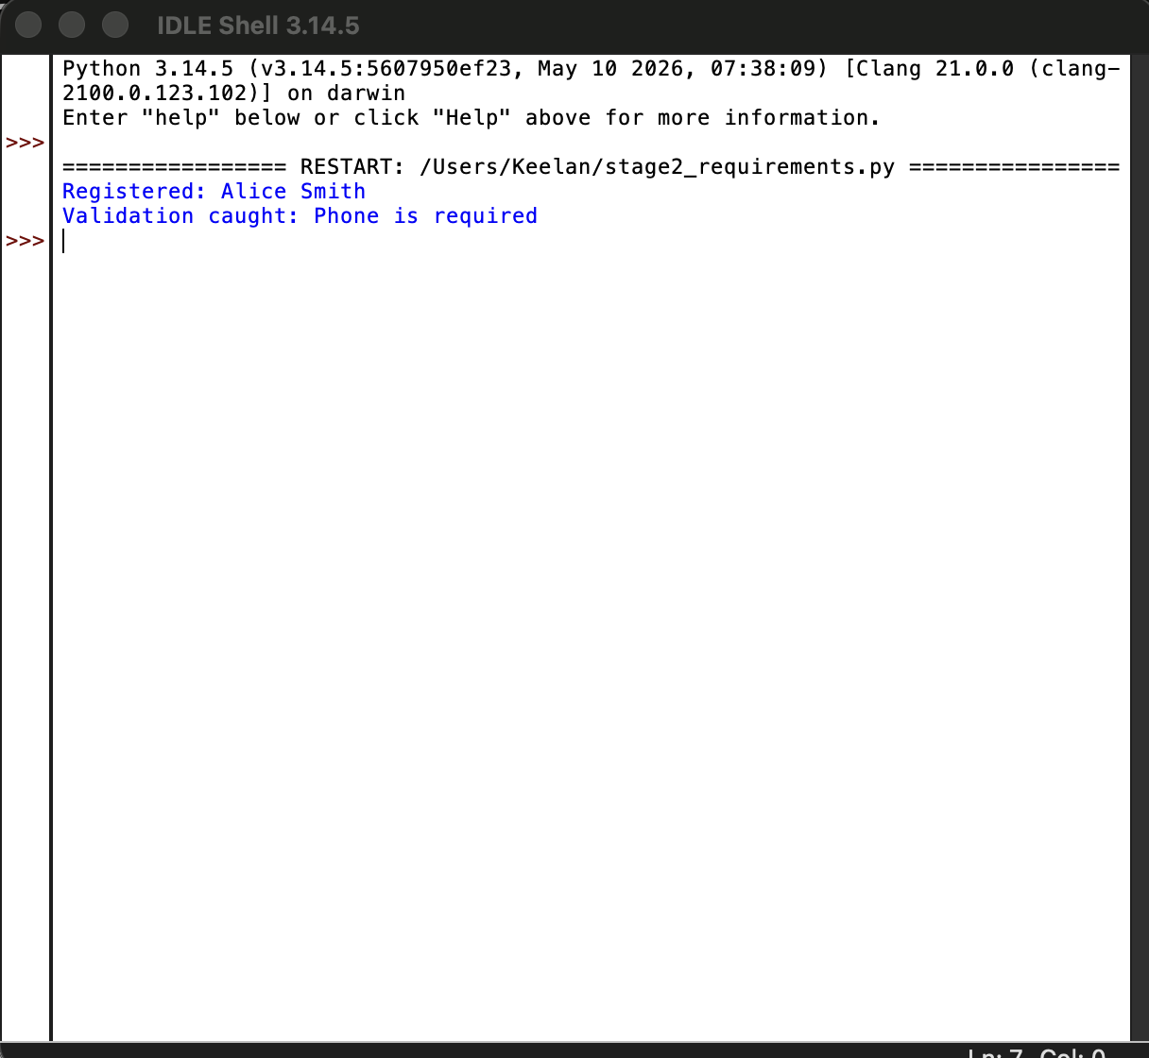
Stage 2 requirements prototype executed successfully via stage2_requirements.py. Implements FR-01 (patient record validation) with input validation for required fields.

8. AI Requirements Review Record
AI suggestion | Evidence? | Decision | Reason | Verification
Add a requirement for user authentication (login) | NFR-06 already covers this. | Accept | Patient data is sensitive, so basic authentication is a reasonable non-functional requirement for staff access. | Added as NFR-06
Add a requirement for rescheduling appointments. | Case study mentions “manual cancellation processes” but not rescheduling. | Reject | Rescheduling is not explicitly mentioned in the case study. It can be added in a later iteration to keep the scope manageable. | Kept out of scope for v0.2.
Clarify the rules for practitioner availability. | The case study mentions “limited visibility of practitioner availability” but does not define what availability means. | Modify | I cannot define the rules without client input, so I added this as an open question in Section 7. | Added to Open Questions.
Consider concurrency (two receptionists booking at the same time). | NFR-03 mentions data integrity. | Keep unverified | This technical implementation detail. For now, I have assumed the application logic will be handled it, but I will verify this in the design stage (Stage 3/4) | Noted for Stage 3
The Fr-01 requirement for a patient record may be missing key fields. | The case study does not specify required patient fields. | Modify | I added “date of birth” and “contact phone number” as reasonable minimum fields, but flagged the full field list as an open question. | Updated FR-01 and Open Questions.

